[font: 12 pt, 2 blank lines]

**Paper title**

**Name and surname**

Author’s institution, title, e-mail address

**Name and surname**

Author’s institution, title, e-mail address

**Name and surname**

Author’s institution, title, e-mail address

[font: 11 pt, 2 blank lines]

**Abstract** [font: 11 pt, bold]: Abstract in Croatian and English, along with key words, must fit on the first page of the article. [font: 11 pt, justified alignment]

[font: 11 pt, 1 blank line]

**Key words** [font: 11 pt, bold]: key words in English [font: 11 pt, justified alignment]

[font: 11 pt, 2 blank lines]

**Naslov rada**

**Sažetak** [font: 11 pt, bold]: Sažetak na hrvatskom i engleskom jeziku, zajedno s ključnim riječima mora se smjestiti u okviru prve stranice članka. [font: 11 pt, justified alignment]

[font: 11 pt, 1 blank line]

**Ključne riječi** [font: 11 pt, bold]: ključne riječi na hrvatskom jeziku [font: 11 pt, justified alignment]

[font: 12 pt, 1 blank line]

**1. TEXT FORMATTING** [font: 12 pt, bold]

[font: 12 pt, 1 blank line]

Text is written in Arial font. The main heading of the chapter is written in font size 12 pt, bold. Subheadings are written in font size 12 pt, bold. The first paragraph starts with no indent, and all other paragraphs in the same chapter are indented by 0.8 cm. Chapter heading or subheading number is followed by a tab character. Body text is aligned justified. [font: 11 pt, first paragraph with no indent]

Text is written in Arial font. The main heading of the chapter is written in font size 12 pt, bold. Subheadings are written in font size 12 pt, bold. The first paragraph starts with no indent, and all other paragraphs in the same chapter are indented by 0.8 cm. Chapter heading or subheading number is followed by a tab character. Body text is aligned justified.

[font: 11 pt, 1 blank line]

**1.1 Chapter subheading**

[font: 12 pt, 1 blank line]

Text is written in Arial font. The main heading of the chapter is written in font size 12 pt, bold. Subheadings are written in font size 12 pt, bold. The first paragraph starts with no indent, and all other paragraphs in the same chapter are indented by 0.8 cm. Chapter heading or subheading number is followed by a tab character. Body text is aligned justified. [font: 11 pt, first paragraph with no indent]

Text is written in Arial font. The main heading of the chapter is written in font size 12 pt, bold. Subheadings are written in font size 12 pt, bold. The first paragraph starts with no indent, and all other paragraphs in the same chapter are indented by 0.8 cm. Chapter heading or subheading number is followed by a tab character. Body text is aligned justified.

[font: 11 pt, 1 blank line]

1

[font: 11 pt, 1 blank line]

Figure 1. Figures and diagrams are aligned to the centre of the page

[font: 11 pt, 1 blank line]

Text is written in Arial font. The main heading of the chapter is written in font size 12 pt, bold. Subheadings are written in font size 12 pt, bold. The first paragraph starts with no indent, and all other paragraphs in the same chapter are indented by 0.8 cm. Chapter heading or subheading number is followed by a tab character. Body text is aligned justified.

Text is written in Arial font. The main heading of the chapter is written in font size 12 pt, bold. Subheadings are written in font size 12 pt, bold. The first paragraph starts with no indent, and all other paragraphs in the same chapter are indented by 0.8 cm. Chapter heading or subheading number is followed by a tab character. Body text is aligned justified.

[font: 11 pt, 1 blank line]

**2. TABLES**

[font: 12 pt, 1 blank line]

Tables are aligned to the centre of the page.

[font: 11 pt, 1 blank line]

Table 1. Tables are aligned to the centre of the page.

[font: 11 pt, 1 blank line]

|  |  |  |  |  |  |
| --- | --- | --- | --- | --- | --- |
| Axis | Moment  (kNm/m) | ACI | FDM | FEM  (Lopes) | Tower |
| 1 | M1 | 268 | 581 | 735 | 698 |
| M2 | -308 | -116 | -118 | -144 |
| M3 | 1034 | 1704 | 2013 | 1903 |

[font: 11 pt, 2 blank lines]

**3. FORMULAS**

[font: 12 pt, 1 blank line]

Formulas are indented by one tab (0.8 cm) and are numbered in the order in which they appear in the text.

[font: 11 pt, 1 blank line]

 (1)

[font: 11 pt, 1 prazna linija]

Formulas are written according to the following template:

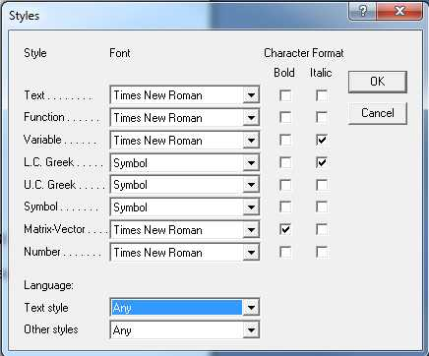

[font: 11 pt, 1 blank line]

Slika 1. This is how to set the Style for Math text in Equation Editor[font: 11 pt, bold]

[font: 11 pt, 2 blank lines]

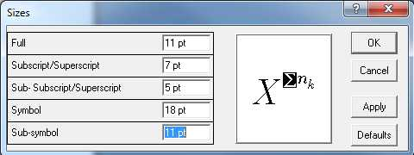

[font: 11 pt, 1 blank line]

**REFERENCES**

1. Author's surname and initials of name: *Full title of cited article*, Journal name, year of publication, issue number, pp. from-to

2. Author's surname and initials of name: *Full title of the book*, Publisher name, place of publication, year of publication