[font: 12 pt, 2 blank lines]

Paper title

Name and surname
Author’s institution, title, e-mail address
Name and surname
Author’s institution, title, e-mail address
Name and surname
Author’s institution, title, e-mail address
[font: 11 pt, 2 blank lines]

Abstract [font: 11 pt, bold]: Abstract in Croatian and English, along with key words, must fit on the first page of the article. [font: 11 pt, justified alignment]
[font: 11 pt, 1 blank line]

Key words [font: 11 pt, bold]: key words in English [font: 11 pt, justified alignment]
[font: 11 pt, 2 blank lines]

Naslov rada

Sažetak [font: 11 pt, bold]: Sažetak na hrvatskom i engleskom jeziku, zajedno s ključnim riječima mora se smjestiti u okviru prve stranice članka. [font: 11 pt, justified alignment]
[font: 11 pt, 1 blank line]

Ključne riječi [font: 11 pt, bold]: ključne riječi na hrvatskom jeziku [font: 11 pt, justified alignment]

[font: 12 pt, 1 blank line]
1. TEXT FORMATTING [font: 12 pt, bold]
[font: 12 pt, 1 blank line]
Text is written in Calibri font. The main heading of the chapter is written in font size 12 pt, bold. Subheadings are written in font size 12 pt, bold. The first paragraph starts with no indent, and all other paragraphs in the same chapter are indented by 0.8 cm. Chapter heading or subheading number is followed by a tab character. Body text is aligned justified. [font: 11 pt, first paragraph with no indent]
Text is written in Calibri font. The main heading of the chapter is written in font size 12 pt, bold. Subheadings are written in font size 12 pt, bold. The first paragraph starts with no indent, and all other paragraphs in the same chapter are indented by 0.8 cm. Chapter heading or subheading number is followed by a tab character. Body text is aligned justified.
The title must be concise and informative, and describe the content of the paper in as few
words as possible. The abstract is limited to a maximum of 120 words.
References used by the author must be listed at the end of the paper. References are listed in
chronological order, in the order they are cited in the text, not alphabetically. In the text, references
are cited using square brackets and numbers: [1], [2]. Thus, the first citation in the text [1] should
correspond to the name [1] in the reference list. The formatting of reference citations is given in the
examples at the end of the instructions. A modified Vancouver style is used for citation formatting.
It is very important to adhere to the punctuation and spacing in the reference list. If the paper
you need to refer to has more than four authors, you should list the first author, followed by 'et al.'.
In the title of a paper/book/report/thesis/website, use sentence case, except for proper nouns.
In the title of a journal, use title case. The use of DOI is recommended.
[font: 11 pt, 1 blank line]
1.1 Chapter subheading
[font: 12 pt, 1 blank line]
Text is written in Calibri font. The main heading of the chapter is written in font size 12 pt, bold. Subheadings are written in font size 12 pt, bold. The first paragraph starts with no indent, and all other paragraphs in the same chapter are indented by 0.8 cm. Chapter heading or subheading number is followed by a tab character. Body text is aligned justified. [font: 11 pt, first paragraph with no indent]
Text is written in Calibri font. The main heading of the chapter is written in font size 12 pt, bold. Subheadings are written in font size 12 pt, bold. The first paragraph starts with no indent, and all other paragraphs in the same chapter are indented by 0.8 cm. Chapter heading or subheading number is followed by a tab character. Body text is aligned justified.
The title must be concise and informative, and describe the content of the paper in as few
words as possible. The abstract is limited to a maximum of 120 words.
References used by the author must be listed at the end of the paper. References are listed in
chronological order, in the order they are cited in the text, not alphabetically. In the text, references
are cited using square brackets and numbers: [1], [2]. Thus, the first citation in the text [1] should
correspond to the name [1] in the reference list. The formatting of reference citations is given in the
examples at the end of the instructions. A modified Vancouver style is used for citation formatting.
It is very important to adhere to the punctuation and spacing in the reference list. If the paper
you need to refer to has more than four authors, you should list the first author, followed by 'et al.'.
In the title of a paper/book/report/thesis/website, use sentence case, except for proper nouns.
In the title of a journal, use title case. The use of DOI is recommended.
[font: 11 pt, 1 blank line]
[font: 11 pt, 1 blank line]
Figure 1. Figures and diagrams are aligned to the centre of the page
[font: 11 pt, 1 blank line]
Text is written in Calibri font. The main heading of the chapter is written in font size 12 pt, bold. Subheadings are written in font size 12 pt, bold. The first paragraph starts with no indent, and all other paragraphs in the same chapter are indented by 0.8 cm. Chapter heading or subheading number is followed by a tab character. Body text is aligned justified.
Text is written in Calibri font. The main heading of the chapter is written in font size 12 pt, bold. Subheadings are written in font size 12 pt, bold. The first paragraph starts with no indent, and all other paragraphs in the same chapter are indented by 0.8 cm. Chapter heading or subheading number is followed by a tab character. Body text is aligned justified.
[font: 11 pt, 1 blank line]
2. TABLES
[font: 12 pt, 1 blank line]
Tables are aligned to the centre of the page.
[font: 11 pt, 1 blank line]
Table 1. Tables are aligned to the centre of the page.
[font: 11 pt, 1 blank line]
Axis | Moment  (kNm/m) | ACI | FDM | FEM  (Lopes) | Tower
1 | M1 | 268 | 581 | 735 | 698
1 | M2 | -308 | -116 | -118 | -144
1 | M3 | 1034 | 1704 | 2013 | 1903
[font: 11 pt, 2 blank lines]

3. FORMULAS
[font: 12 pt, 1 blank line]
Formulas are indented by one tab (0.8 cm) and are numbered in the order in which they appear in the text.
[font: 11 pt, 1 blank line]
(1)
[font: 11 pt, 1 prazna linija]
Formulas are written according to the following template:

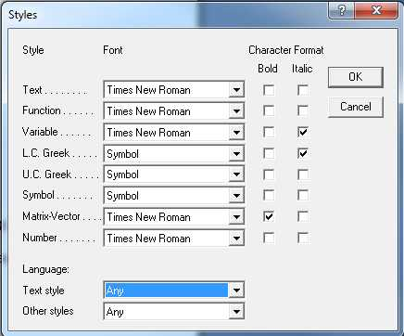
[font: 11 pt, 1 blank line]
Slika 1. This is how to set the Style for Math text in Equation Editor [font: 11 pt, bold]
[font: 11 pt, 2 blank lines]

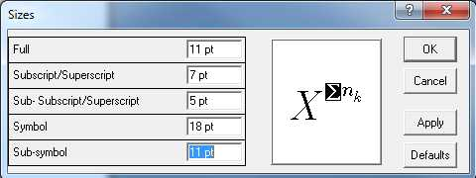
[font: 11 pt, 1 blank line]
REFERENCES

[1] Author's surname and initials of name: Full title of cited article, Journal name, year of publication, issue number, pp. from-to. DOI
[2] Author's surname and initials of name: Full title of the book, Publisher name, place of publication, year of publication. DOI
[3] www...

